System and Software Architecture Description (SSAD)

Web Media Modernization 2012

Team 7

Anvar Bagiyev (Operational Concept Engineer, Tester)
Shawn Han (Software/System Architect, Tester)
Barney Hsiao (Prototyper, Tester)
Prayaas Jain (Feasibility Analyst, Tester)
Samantha Lüber (DEN) (Shaper, QPM, IV&V, Tester)
Adam Smith (Project Manager, Tester)

12/10/2012

Version History
Date | Author | Version | Changes made | Rationale
10/10/2012 | Shawn Han & Prayaas Jain | 1.0 | - Original template for use with Instructional ICM-Sw v1.0 | - Initial draft for use with Instructional ICM-Sw v1.0
10/15/2012 | Shawn Han & Prayaas Jain & Adam Smith | 2.0 | - Completing the Introduction and system analysis | - Based on the system analysis result and ICSM EPG to complete the SSAD
10/29/2012 | Shawn Han & Prayaas Jain | 2.1 | - System Context Diagram, Actor Summary  - Artifacts and Information Diagram  - Process Diagram | - Correct the Diagram with further analysis
11/04/2012 | Shawn Han & Prayaas Jain | 3.0 | - NDI/NCS interoperability analysis | - Analysis the NDI candidates interoperability to promise the cooperate between them
11/26/2012 | Shawn Han | 4.0 | - Change the system context diagram  - Revised the Artifacts and Information Diagram  - Change the use-case diagram and diagram | - Based on the further analysis of the use case
11/27/2012 | Shawn Han | 4.1 | - Improve the use case | - Provide more essential information for alternative/ exception
12/10/2012 | Shawn Han | 4.2 | - Fix the content based on Bugzilla | - Corresponding to Bugzilla

Table of Contents
System and Software Architecture Description (SSAD) i
Version History ii
Table of Contents iii
Table of Tables iv
Table of Figures v
1. Introduction 1
1.1 Purpose of the SSAD 1
1.2 Status of the SSAD 1
2. System Analysis 2
2.1 System Analysis Overview 2
3. NDI/NCS Interoperability Analysis 13
3.1 Introduction 13
3.2 System Structure 14
3.3 Evaluation Summary 14

Table of Tables
Table 1: Actors Summary 3
Table 2: Artifacts and Information Summary 3
Table 3: Process Description-UC1 4
Table 4: Typical Course of Action-UC1 5
Table 5: Alternate Course of Action-UC1 5
Table 6: Exceptional Course of Action-UC1 5
Table 7: Process Description-UC2 6
Table 8: Typical Course of Action-UC2 6
Table 9: Alternate Course of Action-UC2 6
Table 10: Exceptional Course of Action-UC2 7
Table 11: Process Description-UC3 7
Table 12: Typical Course of Action-UC3 7
Table 13: Alternate Course of Action-UC3 8
Table 14: Exceptional Course of Action-UC3 8
Table 15: Process Description-UC4 9
Table 16: Typical Course of Action-UC4 9
Table 17: Alternate Course of Action-UC4 9
Table 18: Exceptional Course of Action-UC4 9
Table 19: Process Description-UC5 10
Table 20: Typical Course of Action-UC5 10
Table 21: Alternate Course of Action-UC5 10
Table 22: Exceptional Course of Action-UC5 10
Table 23: NDI Products Listing 11
Table 24: NDI Evaluation 13

Table of Figures
Figure 1: System Context Diagram 2
Figure 2: Artifacts and Information Diagram 3
Figure 3: Process Diagram 4

Introduction

Purpose of the SSAD
The purpose of the SSAD is to document the results of the analysis and design of the system being developed. The developers use the SSAD as a reference to the system architecture. The system being developed should be faithful to the architecture specified in the SSAD. Furthermore, the maintainer and the client use the SSAD to understand the structure of the system once the proposed system is delivered.

Status of the SSAD
- Sections 1 and 2 have been updated on the basis of the ICSM EPG model and the System Architecture.
- Completing the Introduction and system analysis based on the system analysis result and ICSM EPG
- The System Context Diagram, Actor Summary Artifacts and Information Diagram Process Diagram has been fixed
- NDI/NCS interoperability analysis has been established.
- Update the SSAD to reflect the finished project.

System Analysis

System Analysis Overview
The purpose of revamping the CSC Website is to increase traffic flow to the website. The system intends to achieve the goal of increased traffic flow by using an attractive template and integrating social media components such as Facebook, Twitter, YouTube, Google Plus, LinkedIn into the website. A Google Calendar will be implemented on the website showing all upcoming events. This feature will make it easy for users to subscribe to the calendar and be updated about the events. This will result in increased participation in CSC events as well as the reputation of CSCLA.

System Context

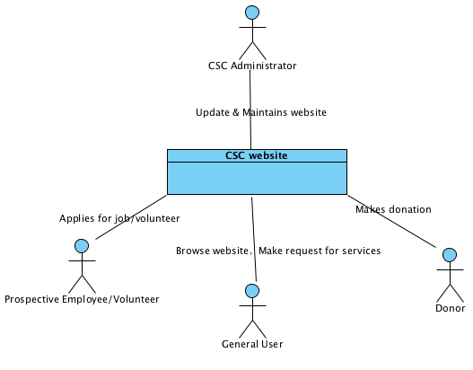

Figure 1: System Context Diagram

Table 1: Actors Summary
Actor | Description | Responsibilities
CSC Maintainer | Member of the CSC Development Team | Maintains and updates the website
Prospective Employee/Volunteer | General user interested in working with/for CSC | Applies for Job/Volunteer position
General User | Any person visiting website | Browses the website
Organization/Individual | Persons catered-to by CSC | Make requests for services to CSC and/or organizes events for CSC
Donor | Person interested in making monetary donations | Makes donation

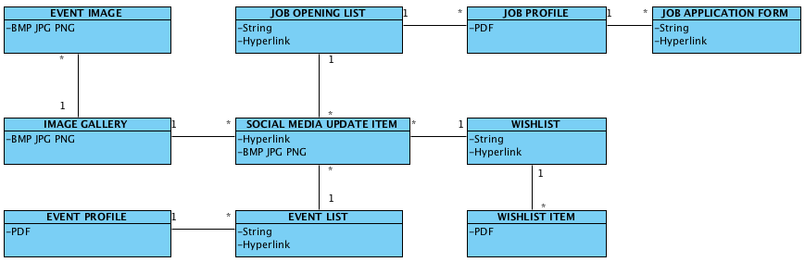
Artifacts & Information
Figure 2: Artifacts and Information Diagram
Table 2: Artifacts and Information Summary
Artifact | Purpose
Social Media Update Item | Gives updates about recent activities by CSC on a public forum (social media websites)
Job Opening List | Gives a list of the Jobs available with CSC
Event List | Gives a list of the upcoming events for the next 90-120 days
WishList | Shows a list of the requests made by the various organizations/individuals
Image Gallery | Shows all images uploaded by CSC
Job Profile | Gives a brief description of what a particular job entails
Job Application Form | Sends information about the applicant to CSC
Event Profile | Gives a brief description about an upcoming event
Event Image | An image uploaded by CSC for their most recent event
WishList Item | A particular request made by an organization/individual

Behavior
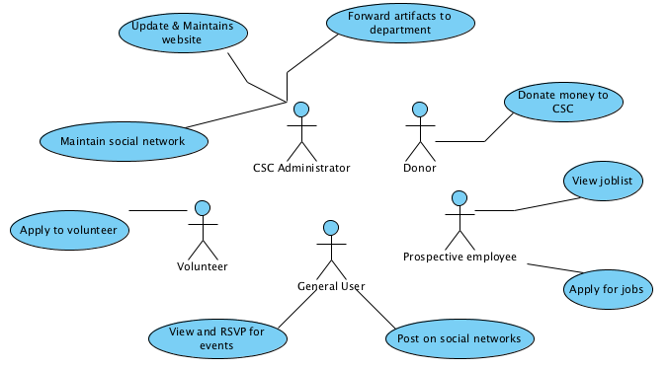
Figure 3: Process Diagram

Calendar Event List

Applying to Volunteer
Table 3: Process Description-UC1
Identifier | UC-1: Volunteers that wish to apply
Purpose | Allow volunteers get the job information and apply easier and save the money and time of paper advertisement for CSC
Requirements | Calendar Event List
Development Risks | None
Pre-conditions | User finds an event they wish to volunteer for on the Community Events page
Post-conditions | User is on the page of Community Events

Table 4: Typical Course of Action-UC1
Seq# | Actor’s Action | System’s Response
1 | User selects the list of upcoming events | System returns and displays a list of upcoming events
2 | User finds an event they wish to volunteer for and selects the corresponding link | System returns and displays the events profile page
3 | Users finds link to apply and selects it | Web page launches the users email client with a new message window prepopulated with the destination email address
4 | User fills out email to apply to be a volunteer, and once finished hits send | System holds email from applicant until the maintainer forwards the email to the correct department

Table 5: Alternate Course of Action-UC1
Seq# | Actor’s Action | System’s Response
1 | User selects the list of upcoming events | System returns and displays a list of upcoming events
2 | User find the event’s link of LinkedIn and click on it | System redirect to the event page of LinkedIn

Table 6: Exceptional Course of Action-UC1
Seq# | Actor’s Action | System’s Response
1 | User selects the list of upcoming events | The CMS/Host server down, f forward to a error page

View and RSVP for Events
Table 7: Process Description-UC2
Identifier | UC-2: Users wish to RSVP for an event
Purpose | Allow users RSVP for an event online so CSC can easily get the static information of the event
Requirements | Calendar Event List
Development Risks | None
Pre-conditions | User finds an event they wish to attend on the Community Events page
Post-conditions | User is on the page of News & Events

Table 8: Typical Course of Action-UC2
Seq# | Actor’s Action | System’s Response
1 | User selects the page of upcoming events | System returns and displays a list of upcoming events with Google Calendar
2 | User finds an event they wish to attend on the static table and selects the corresponding link | System returns and displays the events profile page
3 | Users finds link to RSVP and selects it | System direct to the facebook event page for user to RSVP
Table 9: Alternate Course of Action-UC2
Seq# | Actor’s Action | System’s Response
1 | User selects the page of upcoming events | System returns and displays a list of upcoming events with Google Calendar
2 | User find the upcoming event on the Google Calendar then click on it to check information | Google Calendar shows the detail information of the upcoming events
3 | User finds an event they wish to attend and selects the corresponding link | System returns and displays the events profile page
4 | Users finds link to RSVP and selects it | System direct to the facebook event page for user to RSVP
5 | User login Facebook account or register a new one to finish the RSVP
Table 10: Exceptional Course of Action-UC2
Seq# | Actor’s Action | System’s Response
1 | User selects the page of upcoming events | The CMS/Host server down cannot display the information correctly, forward to a error page

Site Management and Upkeep

Update and Maintain the Website
Table 11: Process Description-UC3
Identifier | UC-4: CSC Maintainer manages website
Purpose | Ease the process of updating the CSC website
Requirements | Site Management and Upkeep
Development Risks | None
Pre-conditions | CSC Maintainer receives a request to update information listed on the website and understand the process of maintain the website through Concrete5 (CMS)
Post-conditions | Administrator is on the Concrete5 website login page

Table 12: Typical Course of Action-UC3
Seq# | Actor’s Action | System’s Response
1 | CSC Maintainer (user) logs into administrator panel of the website with correct information | The credentials are correct the user is allowed into the administrator panel
2 | User navigates to the page that needs to be updated and selects “Edit” | System opens the page in edit mode allowing the user to make changes to content
3 | User updates the data using the WYSIWYG editor and hits Save when finished | System saves the changes to the page
Table 13: Alternate Course of Action-UC3
Seq# | Actor’s Action | System’s Response
1 | CSC Maintainer (user) logs into administrator panel of the website with incorrect password or username | Reject the login attempt and show the page of forget the username/password page
2 | CSC Maintainer (user) provides the essential information to the database system | system verify the information and reset the password in the database
3 | CSC Maintainer (user) logs into administrator panel of the website with correct information | If the credentials are correct the user is allowed into the administrator panel
4 | User navigates to the page that needs to be updated and selects “Edit” | System opens the page in edit mode allowing the user to make changes to content
5 | User updates the data using the WYSIWYG editor and hits Save when finished | System saves the changes to the page
Table 14: Exceptional Course of Action-UC3
Seq# | Actor’s Action | System’s Response
1 | CSC Maintainer (user) logs into administrator panel of the website | The CMS server down, forward to a error page

Viewing Job List
Table 15: Process Description-UC4
Identifier | UC-5: Viewing job listings
Purpose | Allow the job applicants to find open positions at CSC
Requirements | Site Management and Upkeep
Development Risks | None
Pre-conditions | Applicant navigates to the CSC website to look for jobs
Post-conditions | User is on the CSC main page

Table 16: Typical Course of Action-UC4
Seq# | Actor’s Action | System’s Response
1 | Job applicants (users) will select the Jobs link on the main page | System will return and display a list of active jobs
2 | User will select jobs from the list to view more information | System will return the information for the particular job and display it on the webpage

Table 17: Alternate Course of Action-UC4
Seq# | Actor’s Action | System’s Response
1 | Job applicants (users) will select the Jobs link on the main page | System will return and display a list of active jobs
2 | User select the job and click on the LinkedIn job page link | System show the LinkedIn job page
Table 18: Exceptional Course of Action-UC4
Seq# | Actor’s Action | System’s Response
1 | Job applicants (users) will select the Jobs link on the main page | The CMS/Host server down cannot display the information correctly, forward to a error page

Donating Money to CSC
Table 19: Process Description-UC5
Identifier | UC-6: Donating money
Purpose | Allow users to donate money
Requirements | Wish List for Donations
Development Risks | None
Pre-conditions | User has money to donate to CSC or for wish list item
Post-conditions | Donor is on the CSC main page

Table 20: Typical Course of Action-UC5
Seq# | Actor’s Action | System’s Response
1 | Donors (users) select the Donation button in the top right | System will forward the user to the PayPal donation page (located on PayPal.com) for the CSC
2 | Donors choose Paypal as the method for donation | System show Paypal donation page
Table 21: Alternate Course of Action-UC5
Seq# | Actor’s Action | System’s Response
1 | Donors (users) will navigate to the webpage and select the Donation button in the top right | System will forward the user to the PayPal donation page (located on PayPal.com) for the CSC
2 | Donors choose other way such as by mail, phone, or email to donate | System show the instruction page for particular donation method.
Table 7: Exceptional Course of Action-UC5
Seq# | Actor’s Action | System’s Response
1 | Donors (users) will navigate to the webpage and select the Donation button in the top right | System will forward the user to the PayPal donation page (located on PayPal.com) for the CSC
2 | Donors choose Paypal as the method for donation | The Paypal system unavailable, forward to a error page

NDI/NCS Interoperability Analysis

Introduction
In this project, Content Management System(CMS) will be use to interoperate with social media network API such as Twitter, Facebook, LinkedIn, YouTube.

COTS / GOTS / ROTS / Open Source / NCS
Table 23: NDI Products Listing
NDI/NCS Products | Purposes
CushyCMS  Concrete5  Drupal  WordPress | Website development and maintenance
Google Calendar API | Implement Events List
Google Map API | Implement CSCLA site information
YouTube API | Link to YouTube channel and YouTube Plug-in on website

Connectors
In our project, instead of using a Connectors, writing API source code in our website through Content Management System (CMS) is enough to promise those NDI/NCS working together well.

Legacy System
- This system should work well on the Google Chrome (Version 23.0), Firefox (Version 16) which are the most popular web browsers.

System Structure
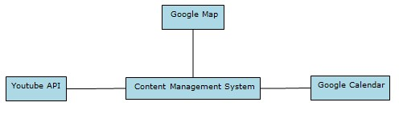

Evaluation Summary
Table 24: NDI Evaluation
NDI | Usages | Comments
Concrete5 | Website development and maintenance | - Very easy and flexible to build a new website  - Attractive template and API store  - Good version control  - Team member has experience with Concrete5
Drupal | Website development and maintenance | - Free good model which still maintains by developer  - Easy for developer but not for designer or maintainer
WordPress | Website development and maintenance | - Good for heavy website  - High-profile WordPress sites  - Not easy to customize website as Concrete5
CushyCMS | Website development and maintenance | - No theme library available  - Administration panel with lots of advertisement for free version  - Not as easy and flexible as Concrete5
Google Calendar API | Implement events list | It will enable users to subscribe to the list events
Google Maps API | Implement map | It will enable user to have direct understanding of where all CSCLA office are
YouTube API | Implement link to YouTube channel and YouTube Plug-in on website | It will provide users with a link to the CSC YouTube channel and will enable maintainers to post videos on the CSC website using the plug-in

We only have the candidates for CMS.
For the rest NDIs, which are all requested by the client, no candidates for them.

